**Curriculum Vitae**

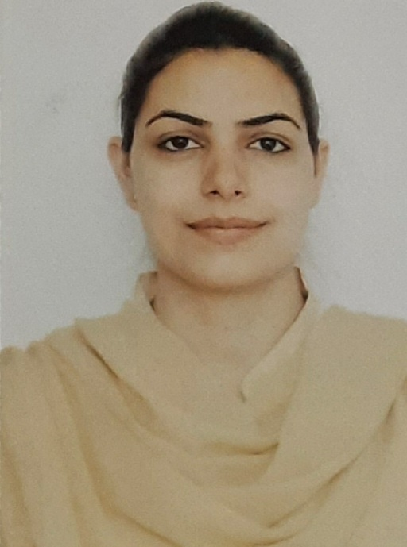

**Dr. Sheetu Raina**

Assistant Professor in Zoology

GGM Science College,

Higher Education Department,

Jammu & Kashmir, India.

Email id: rimi.raina15@gmail.com

Contact no.: 7006533476

**Academic Qualification:**

**•** Ph.D Zoology on topic “Effect of Environmental Stress on Haematology and Immune Organs of *Labeo* Species” from University of Jammu, 2012.

**•** MSc. Zoology, University of Jammu, 2007

**•** BSc. University of Jammu, 2005.

**Research Papers Published:**

* **2021:**Importance of nutraceuticals in various diseases and human health: A comprehensive review. International organization of Scientific research, Journal of Environmental science, toxicology and food technology. Volume 15(11), 41-55, ISSN: 2319-2399.
* **2014:** Effect of heavy metal, zinc and carbamate pesticide, sevin on haematological parameters of fish, *Labeo boga*. International Journal of Innovative Research in Science, Engineering and Technology. Volume 3, issue 5, ISSN: 2319-8753.
* **2014:** Effect of lindane on immune organs of the fish, *A*. *morar*. International Journal of Innovative Research in Science, Engineering and Technology. Volume 3(1), 8510-8515, ISSN: 2319-8753.
* **2014:** Effect of starvation on haemopoietic organs of fish *Labeo boga*. International Journal of Innovative Research in Science, Engineering and Technology. Volume 3(1), 10129-10135, ISSN: 2319-8753.
* **2014:** Effect of inorganic pollutant (nitrate) on biochemical parameters of the fish, *Aspidoparia morar*. International journal of Innovative Research in Science, Engineering and Technology. Volume 3(5), 12568-12573, ISSN: 2319-8753.
* **2014:** Haematological alterations induced by lindane in a fish, *Aspidoparia morar*. Global Journal of Biology, Agriculture and health Sciences. Volume 3(1), 38-42, ISSN: 2319-5584.
* **2014:** Effect of starvation on immune organs of fish *Labeo* *boga*. Global Journal of Biology, Agriculture and health Sciences. Volume 3(1), 11-15, ISSN: 2319-5584.
* **2013:** Histopathological alterations induced by lindane (gamma-hexachlorocyclohexane) in a minor carp, *Aspidoparia morar* inhabiting Jammu waters. International Journal of Scientific and Research Publications. Volume 3(4), 1-6, ISSN: 2250-3153.
* **2013:** Haematological response of freshwater fish *Puntius* *sophore* (HAM.) to copper exposure. International Journal of Scientific and Research Publications. Volume 3(5), 1-6, ISSN: 2250-3153.
* **2013:** Seasonal Variations in Haematological parameters of Golden Mahseer, *Tor putitora*. International Journal of Scientific and Research Publications. Volume 3(6), 1-6, ISSN: 2250-3153.
* **2012:** Age and size related variations in the haematological parameters of *L. boga* and *L. bata*. Biosciences Biotechnology Research Asia. Volume 9(1), 437-440, ISSN: 0973-1245.
* **2012:** Sex related seasonal variations in the Haematological parameters of *Aspidoparia morar* and *Barilius vagra*. International Journal of Advanced Biotechnology Research. Volume 2(1), 21-27, ISSN: 2249-3166.
* **2012:** Haematological changes induced by starvation in Minor Carp, *Labeo boga* (HAM.). Journal of the Inland Fisheries Society of India. Volume 44(2), 56-61. ISSN: 0379-3435.
* **2011:** Biochemical alterations induced by lindane in a fish, *Aspidoparia morar*. International Journal of Applied Biotechnology and Biochemistry. Volume 1(1), 95-102, ISSN: 2248-9886.
* **2011:** Impact of chronic zinc exposure on haematological parameters of Minor Carp, *Labeo boga* (Ham.). International Journal of Applied Biotechnology and Biochemistry. Volume 1(1), 231-238, ISSN: 2248-9886.
* **2009:** Effect of lindane on the haemopoietic tissues in a minor carp *Labeo boga* (Ham.). Biomedical and Pharmacology Journal. Volume 2(2), 281-286, ISSN: 0974-6242.
* **2009:** Effect of lindane on haematological indices of minor carp *Labeo boga* (Ham.). Biosciences, Biotechnology Research Asia. Volume 6(2), 695-702, ISSN: ISSN: 0973-1245.
* **2009:** Effect of eye- stalk ablation on reproduction in female prawn *Macrobrachium dayanum*. Biomedical and Pharmacology Journal. Volume 2(2), 417- 42, ISSN: 0974-6242.

**Induction/orientation courses attended:**

* 3-week induction/orientation programme from Government College of Education, Jammu w.e.f 10th to 29thApril, 2017.
* 4-week induction/orientation programme from Teaching Learning Centre, Ramanujan College, University of Delhi, sponsored by Ministry of Human Resource Development w.e.f. 4th June to 1st July 2020.

**FDP/Refresher courses attended:**

* 2-week Faculty Development Programme on “Managing online classes and co-creating MOOCS 3.0” from Teaching Learning Centre, Ramanujan College, University of Delhi, sponsored by Ministry of Human Resource Development w.e.f. 25th July to 10th August, 2020.
* Participated in Inter-disciplinary Refresher course in disaster management organized by UGC-HRDC University of Jammu w.e.f 15th to 28th Feb., 2021
* 2-week Inter-disciplinary Faculty Development Programme on “Managing online classes and co-creating MOOCS 6.0” from Teaching Learning Centre, Ramanujan College, University of Delhi, sponsored by Ministry of Human Resource Development w.e.f. 5th July to 19th July, 2021.
* 2-week Refresher course in Zoology Teaching Learning Centre, Ramanujan College, University of Delhi, sponsored by Ministry of Human Resource Development in collaboration with department of Zoology, PSGRK College for women, Coimbatore, Tamil Nadu w.e.f. 15th to 29th Dec., 2021.

**Participation in workshops:**

* Participated in two-day National level E-Workshop on “Understanding OBS Studio and Streamyard for E- Content creation and live streaming” organized by Faculty of humanities and Science, Dr. M.G.R. Educational and Research Institute w.e.f. 10th -11th July 2020.
* Participated in seven days E-Workshop on “Entrepreneurial skill development and career opportunities in biological sciences” organized by Zoology and Biotechnology Department from 24th to 30th June, 2021 organized by Girl's P.G. College, M.P. w.e.f. 1st to 3rd March, 2021.

**Conferences/ Seminars Attended:**

* 101th Indian Science Congress held at University of Jammu, Jammu from 3rd to 7th Feb., 2014.
* National seminar on Biodiversity: Sustainable development and Conservation, Department of Zoology, University of Jammu w.e.f 6th to 8th March, 2014.
* One Day Conference on Environmental Pollution: Impact, consequences and remedial measures.
* 7th JK Science Congress (JKSC-11) w.e.f 13th to 15th Oct, 2011.
* 5th JK Science Congress w.e.f. 8th to 10th Feb., 2010.
* 3rd JK Science Congress w.e.f. 26th to 28th Feb., 2008.
* National Seminar on status of Biodiversity and conservation at Gurukul Kangri Vishwavidyalaya, Haridwar w.e.f. 27th to 28th Feb., 2009.

**Participation in webinars:**

* Participated in an online National Webinar on “Importance of Extension Activities in Higher Education” organized by Department of Lifelong Learning and Extension, KLE Society's Science and Commerce College, University of Mumbai on 24th July, 2020.
* Participated in an online webinar on “one year of the repeal of article 370: implications and outcomes” from Teaching Learning Centre, Ramanujan College, University of Delhi, sponsored by Ministry of Human Resource Development on 5th August, 2020.
* Participated in an online two-day webinar on “Harnessing Science and Technology for Women's welfare in Jammu region” organized by co-jointly by GDC. Chennai and GCW, Parade w.e.f. 16-17th December,2020.
* Participated in an online International webinar on “Role of Science and Technology in Global Health and Food Security.” Organized by Govt. Girl's P.G. College, M.P. w.e.f. 1st to 3rd March, 2021.

**Research papers presented in International or National conferences/Seminars:**

* Presented research paper in three-day International Conference on “water conservation” held at GDC Udhampur from 29th Feb. to 2nd March, 2020.
* Presented research paper in one day seminar on “technology, tradition, heritage and culture” organized by GDC Udhampur on 26th March, 2019.
* Presented research paper in 7th JK Science Congress (JKSC-11) w.e.f 13th to 15th Oct, 2011 in Department of Zoology, University of Jammu, Jammu.
* Presented research paper in National Seminar on status of Biodiversity and conservation at Gurukul Kangri Vishwavidyalaya, Haridwar w.e.f. 27th to 28th Feb., 2009.
* Participated and qualified the International E-Quiz on “Environmental Science” from S.D. Kenya Mahavidyala, Mansa affiliated to Punjab University w.e.f. 25th July to 30th July, 2020.

**Appreciation award:**

* Received appreciation letter as Nodal officer of Red Ribbon Club, GDC Bishnah from J&K AIDS Control Society, H&ME Department in execution of the activities under Implementation of New India @75 throughout J&K.
* Received appreciation letter as Nodal officer of Red Ribbon Club, GDC Bishnah from J&K AIDS Control Society for th FY 2021-2022 for organizing various awareness campaigns in making our J&K free from HIV, TB and Covid-19.

**Teaching Experience:**

* Joined Higher Education Department on 7th April, 2017
* Worked in GDC Udhampur from 26th May, 2017 to 29th June, 2019.
* Worked in GDC Bishnah from 1st July, 2019 to 5th October, 2023.
* Working in GGM Science College from 6th October, 2023 till date

**Members of committees constituted at different colleges**

* College Development Committee
* Examination and Internal cell Committee
* Dean Students Welfare Committee
* College admission Committee
* College Library Committee
* College Beautification Committee
* College Eco club Committee
* College Science Club
* College NSS Unit
* Tour and Picnic Committee
* Nodal officer Red Ribbon Club

**Languages known:**

* English, Hindi, Kashmiri

Date:

Place: